**EXP.NO:06**

**DATE:10/02/2023**

**CREATE A SIMPLE WEB SITE USING ANY PUBLIC CLOUD SERVICE PROVIDER (AZURE) AND CHECK THE PUBLIC ACCESSIBILITY OF THE STORED FILE TO DEMONSTRATE STORAGE AS A SERVICE**

**AIM:**

To Create a simple web site using any public cloud service provider (azure) and check the public accessibility of the stored file to demonstrate storage as a service

**PROCEDURE:**

1. Firstly go to app service to create an webapp
2. enter the resource group and webapp name and region and select the Linux OS.
3. after enter the all the necessary things click the review and create and click the create the web app.
4. And our deployment is completed.
5. Go to website URL link.
6. This is our webapp service.

**IMPLEMENTATION:**

**STEP1: FIRSTLY GO TO APPSERVICE TO CREATE AN WEBAPP.**

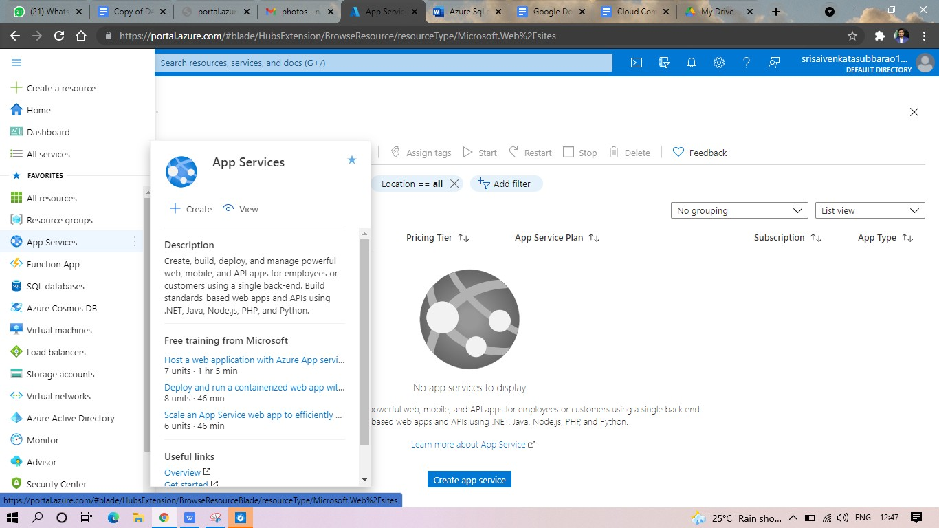

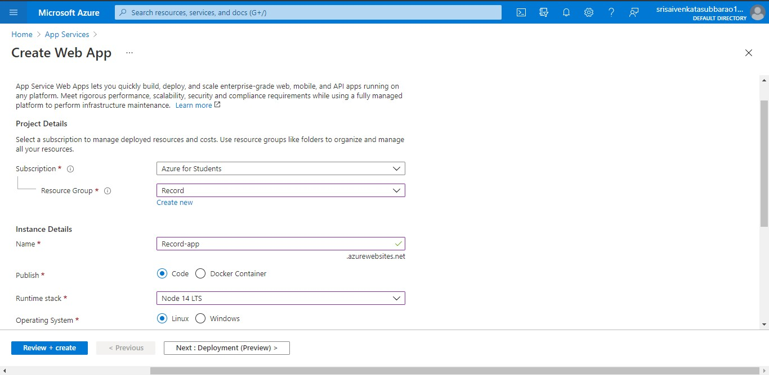**STEP2: ENTER THE RESOURCE GROUP AND WEBAPP NAME AND REGION AND SELECT THE LINUX OS.**

**STEP3: AFTER ENTER THE ALL THE NECESSARY THINGS CLICK THE REVIEW AND CREATE AND CLICK THE CREATE THE WEB APP.**

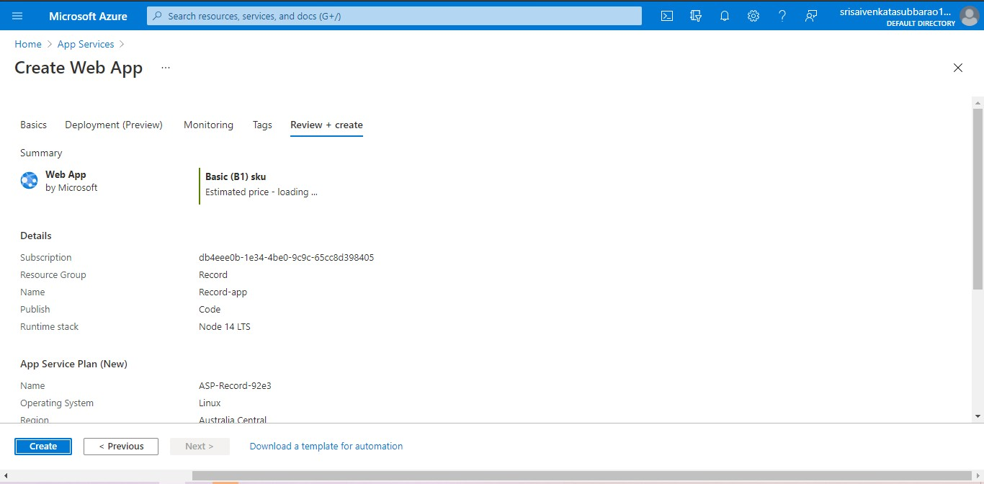

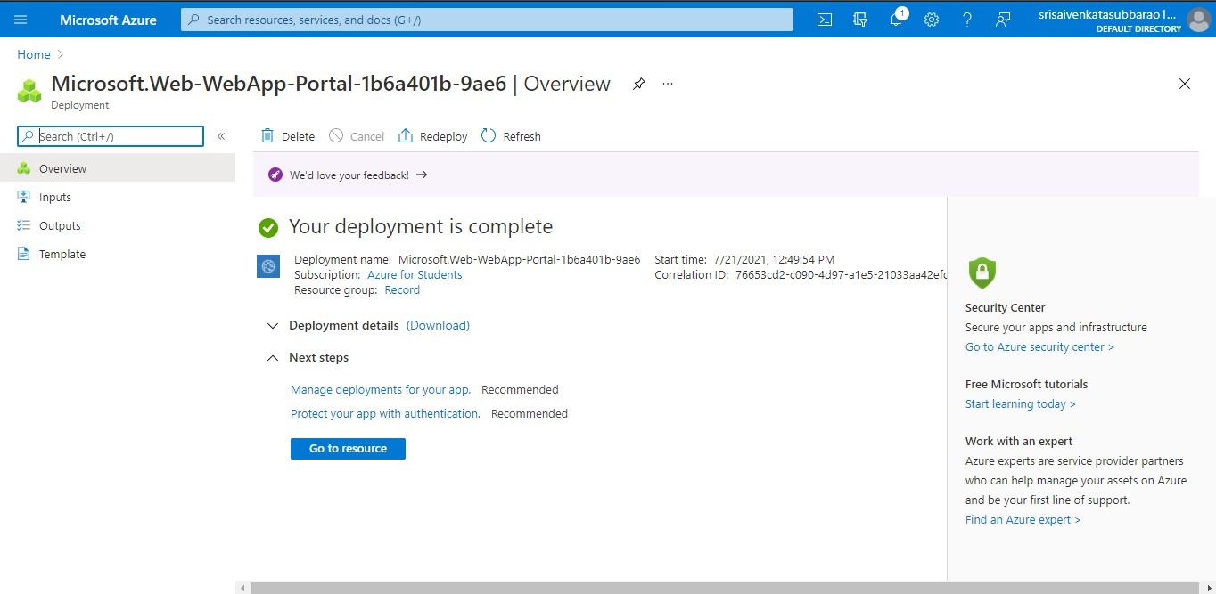**STEP4: AND OUR DEPLOYMENT IS COMPLETED.**

**STEP5: GOTO WEBSITE URL LINK.**

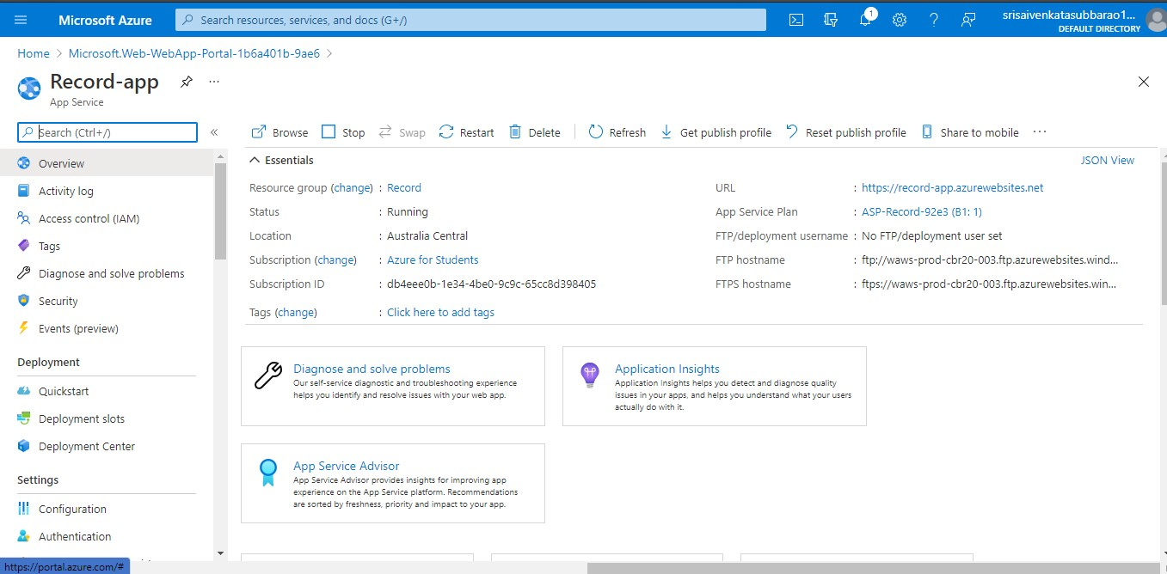

**STEP6: THIS IS OUR WEBAPP SERVICE.**

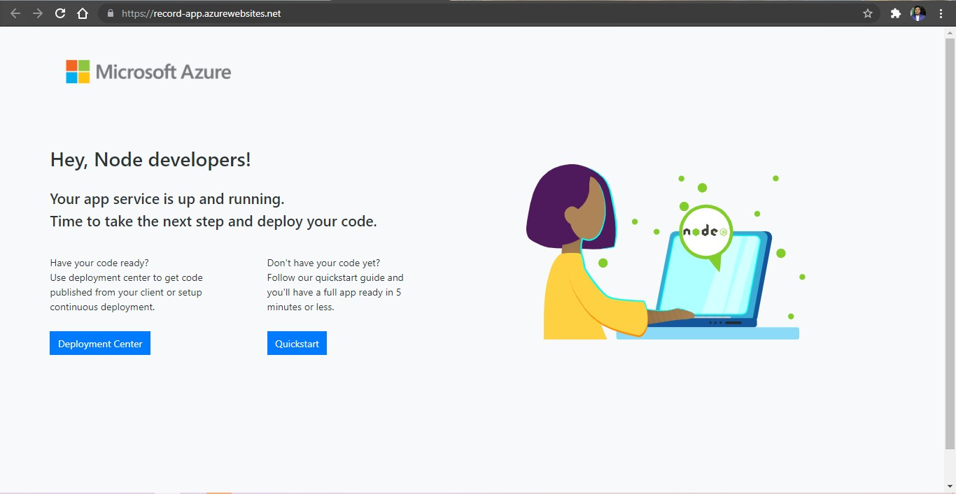

**OUTPUT**

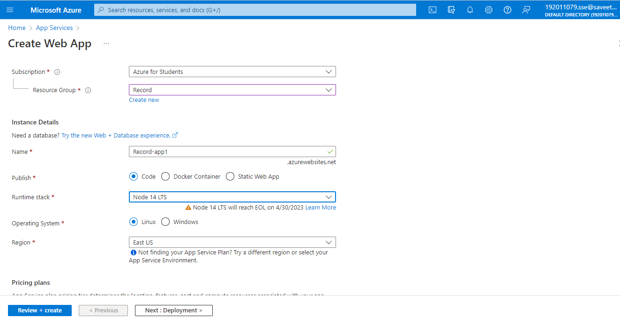

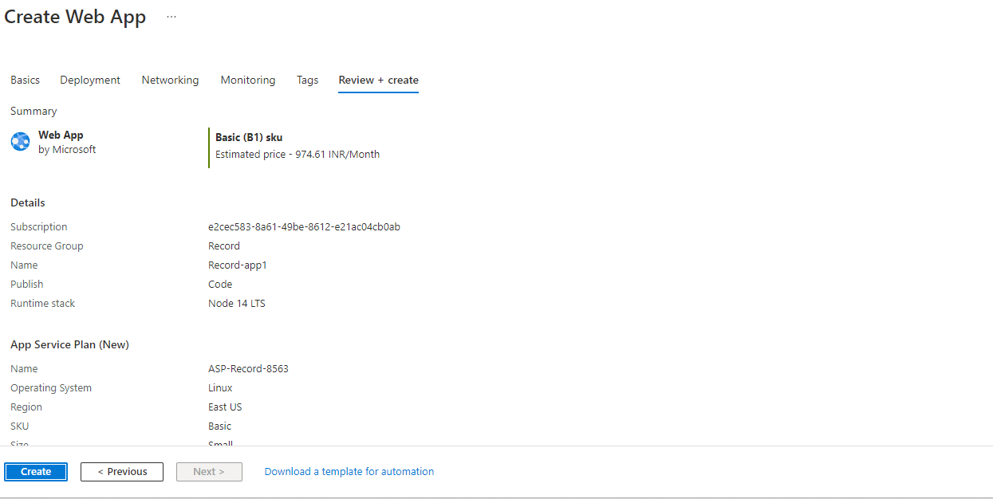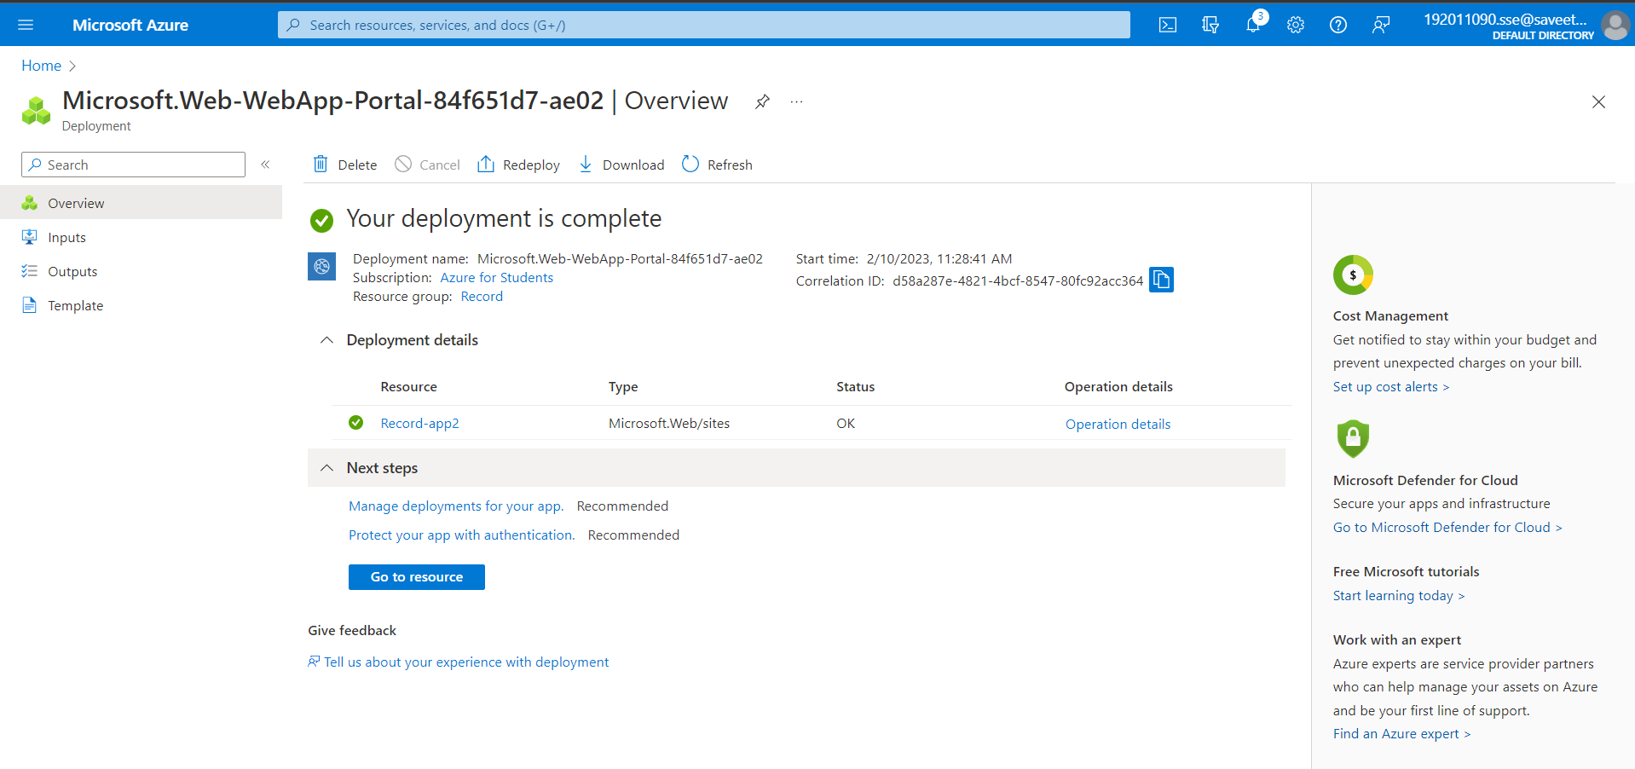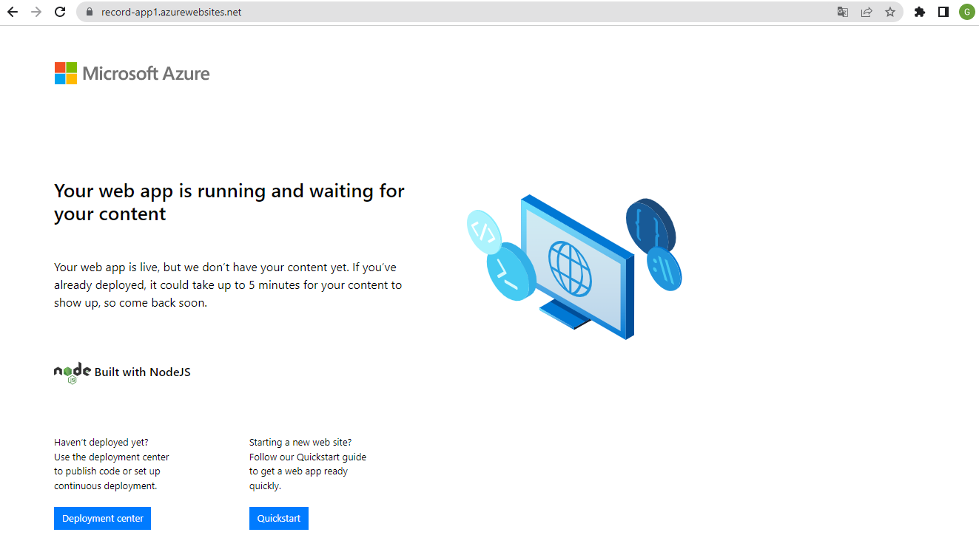

**RESULT**

Hence the creation a simple web site using any public cloud service provider (azure) and check the public accessibility of the stored file to demonstrate storage as a service is executed successfully.